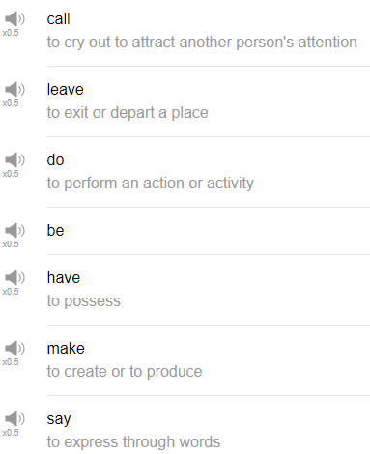

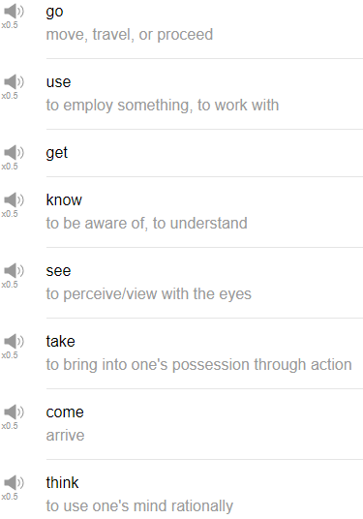

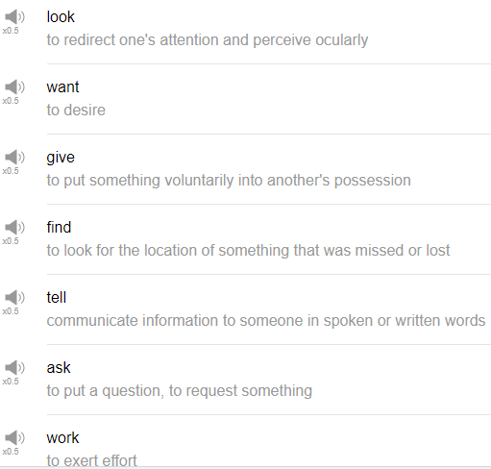

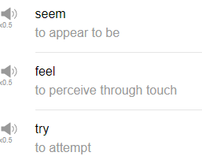

|  |
| --- |
| Hi everybody. My name is Alisha and today we are going to be talking about the top 25 English verbs by frequency. So let’s get into it! |
| 1. “Be” is the first English verb. |
| Be refers to existence. |
| I want to be an astronaut. |
| I think you would be a great person for this job. |
| Be yourself, let’s be friends. |
| I could have been a writer if I wanted to be. |
| 2. The next verb is “have”. |
| I have a dog. |
| I have an idea. |
| What do you have? |
| How many do you have? |
| How much money do you have? |
| Do you have any friends? |
| How have you been? |
| Have you seen my mom? I can’t find her. |
| Have yourself a Merry Little Christmas. |
| 3. The next verb is “do”. |
| Do you want some pizza? |
| Do you have a dog? |
| Dooby Dooby Doo if you are Frank Sinatra. |
| I do the things but you do better. |
| 4. “Say” |
| Say, say, say, say what you want, say my name, say you love me. |
| Do you know what I am saying, know what I am saying. |
| 5. The next verb is “get”. |
| Get a life. |
| Get a job. |
| Get a haircut. |
| Get a better suit, Stevens. |
| What you got? |
| I could have gotten pony but I went with a lizard instead. |
| I am getting tired, that’s not true. |
| 6. The next verb is “make”. |
| Make a cake. |
| Make your mother proud. |
| Someone outside is making a strange face at me through the window at the moment. That is a true story. |
| Make a living through legitimate means. |
| 7. The next verb is “go”. |
| Go big or go home. |
| I am going to the beach, you should go to the beach. |
| You should go to the forest. |
| Go to a baseball game with me. |
| Past tense of go is “went”, I went…. spelunking on my holiday. |
| 8. The next word is “know”. |
| This is an interesting word because no is actually not commonly used in the progressive tense. Know is commonly used in present tense to refer to your mental state or your emotional state. So we don’t really say I am knowing really but we can say I know. |
| I know the answer. |
| What do you know about this issue? |
| He couldn’t have possibly known the location of the treasure. |
| How many people do you know? |
| I knew it. |
| 9. The next verb is “take”. |
| Take a cake. |
| Take a break. |
| Take yourself to bed. |
| You should take a vacation. |
| Have you ever taken a bath. |
| 10. And next word is “see”. |
| We will see, I will see you later. |
| 11. The next verb is “come”. |
| Come is the next verb. |
| Please come to my house. |
| Come to a party. |
| I am going to come over to your place later. |
| 12. The next word is “think”. |
| Think. I think you are great. |
| He thinks pizza is the best food. |
| I am thinking about lunch. I am thinking about coffee. |
| What are you thinking about? I’ve been Thinking ‘Bout Somethin’. That’s a Hanson song. |
| Have you ever thought about the meaning of life. |
| 13. “Look”, look is the next verb. |
| Please look at the camera. |
| Look over there. |
| Look over here. |
| Look at dog,. |
| Look at your mom. |
| Oh my gosh, would you look at that! |
| Look at the time,. |
| Look! It’s a bird, it’s a plane, it’s actually a bird, look at that. |
| Is it me you are looking for, hello. |
| 14. Next word is “want”. |
| Want, what do you want? I want food. |
| How many coffees have you ever wanted. |
| I wanted to go to the dry-cleaner this morning but I ran out of time, that’s true. |
| 15. The next verb is “give”. |
| Give me a break. |
| I am going to give you a raise, Stevens. |
| I am giving you the X, Fired. |
| Gimme a break, Gimme a break, Break me off a piece o' that Kit Kat bar. |
| I have given you everything I have, go on to Mordor, Frodo. |
| I could have given you the world and instead I gave you a carpet. |
| 16. “Use” is the next word, use. |
| Don’t use a pen. |
| I like using chocolate when I make food. |
| Are you using me for my brain? |
| 17. Next is “find”. |
| We could have found buried treasure last weekend. |
| I am finding Nemo. |
| Find things on the internet with Google. |
| Find English words and phrases at englishclass101.com, yeah. |
| 18. “Tell” is the next verb. |
| Tell me a story. |
| Tell me lies, tell me sweet little lie. |
| Tell me the truth, the whole truth and nothing but the truth. |
| I am told that you are an extremely good opera singer. |
| I am telling you to leave. |
| Tell lies every day. |
| Don’t tell lies. |
| 19. The next word is “ask”, ask. |
| Please pronounce this correctly. It is not axe. Many native speakers make this pronunciation mistake and it really bothers me, ask. |
| Ask me about my collection of rare donut recipes. |
| Ask your mom about her life. |
| Why don’t you ask your boss to the party? |
| How about you ask your co-worker for some advice about this issue. |
| I should have asked for help but I didn’t. |
| 20. The next verb is “work”. |
| Work is work. |
| I am working now. |
| 21. “Seem”, to seem. |
| The weather seems nice today. |
| He seemed a little angry this morning. |
| 22. “Feel” is the next word. |
| Feel, I feel happy, feelings. |
| How does it feel, feel, feel, Clap along if you feel like that's what you wanna do. |
| 23. “Try”, oh my gosh! |
| Try is the next word. Hah |
| I am trying my best. |
| I try everyday to work very hard. |
| Have you ever tried Ramen? |
| I tried Ramen yesterday and it was really good. |
| Do you try to exercise every day? |
| I am trying to sleep, go away. |
| 24. The next verb is “leave”, leave. |
| Leave me alone. |
| Leave your doors unlocked. |
| Don’t leave your doors unlocked. |
| I have never left a hotter balloon without first taking the picture. |
| 25. The next verb is “call”. |
| Call is the next verb. |
| Give me a call. |
| Please call me later. |
| Call me maybe. |
| Call your mom on her birthday every year, she will be happy. |
| Call, call, there is a seagull. |
| Have you ever called the wrong number? |
| Have you ever called a dog by another dog’s name? |
| And that’s the end of the most fun episode I’ve ever done I think. |
| So those are 25 English verbs, some very, very common English verbs. Give them a try. We’ve talked about a lot of different grammar forms and a lot of different ways, you can use these verbs. So please practice them and if you like this video, please be sure to comment. Please be sure to subscribe too. We will have a button around here somewhere. Many, many buttons. So please subscribe to us and check out more content as it becomes available. Thanks very much and we will see you again soon, bye. Look at that. Leave your attitude at the door. There are a lot of verbs in English. Okay these are just a few. |